**DAILY ONLINE ACTIVITIES SUMMARY**

|  |  |  |  |  |  |  |  |
| --- | --- | --- | --- | --- | --- | --- | --- |
| **Date:** | **29/05/2020** | | | | **Name:** | **Amrutha G** | |
| **Sem & Sec** | **4TH&A** | | | | **USN:** | **4AL18CS006** | |
| **Online Test Summary** | | | | | | | |
| **Subject** | | **OPERATEING SYSTEM** | | | | | |
| **Max. Marks** | | **30** | | **Score** | | **27** | |
| **Certification Course Summary** | | | | | | | |
| **Course** | **Introduction to digital marketing**  **Marketing foundation** | | | | | | |
| **Certificate Provider** | | | **UDEMY** | **Duration** | | | **2.5 hours**  **2.25 hours** |
| **Coding Challenges** | | | | | | | |
| **Problem Statement:1: Write a C Program to generate first N Armstrong Numbers**  **Problem Statement 2: Write a Java program to Find size of the largest ‘+’ formed by all ones in a binary matrix** | | | | | | | |
| **Status: executed** | | | | | | | |
| **Uploaded the report in Github** | | | | **YES** | | | |
| **If yes Repository name** | | | | **https://github.com/AMRUTHAGANESH/lockdown-codings** | | | |
| **Uploaded the report in slack** | | | | **YES** | | | |

Online Test Summary: 18CS43 online test was scheduled from 9:00am to 9:45 am. The portion for the IA was 2nd module. The question were MCQ type There were 30 question 1 mark respectively duration is 40 minutes .The score I received was 27/30.

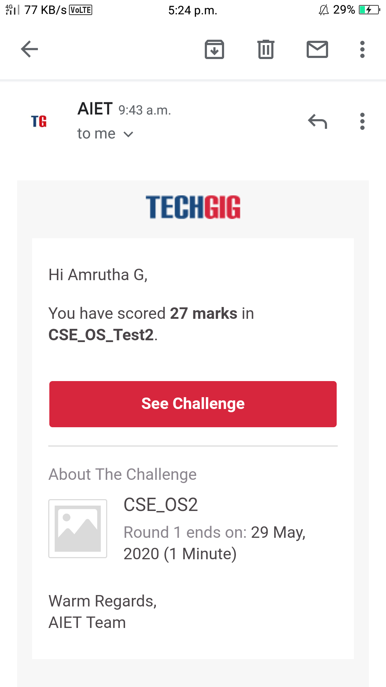

Online Certification course:

Name of the course: Introduction to digital marketing

Certificate provider :great learning academy

Today I have successfully completed Introduction to digital marketing

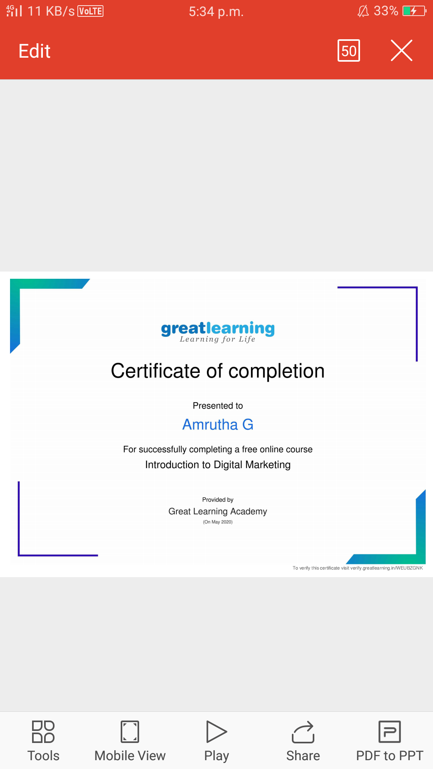

Today I also started new course

Name of the course : marketing foundation

Today I completed all the modules in marketing foundation



**This is the snapshot of the course.**

Online Coding summary:

1. **Write a C Program to generate first N Armstrong Numbers.**

**Snap shot**

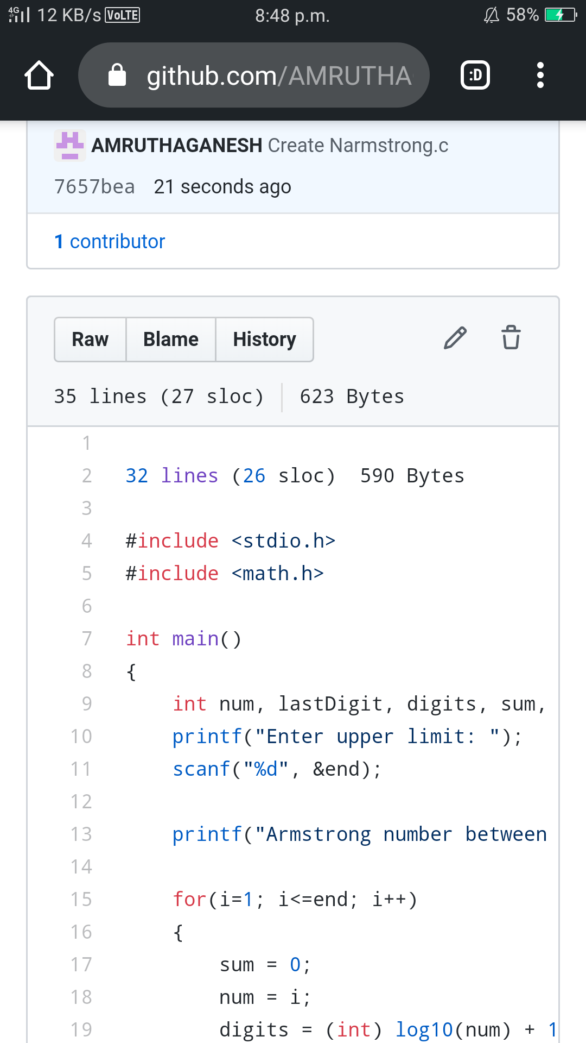

2. **Write a Java program to Find size of the largest ‘+’ formed by all ones in a binary matrix**

**Snap shot**

